BASIC QUERIES FOR MYSQL DATABASE

1.Query To Create a Table:

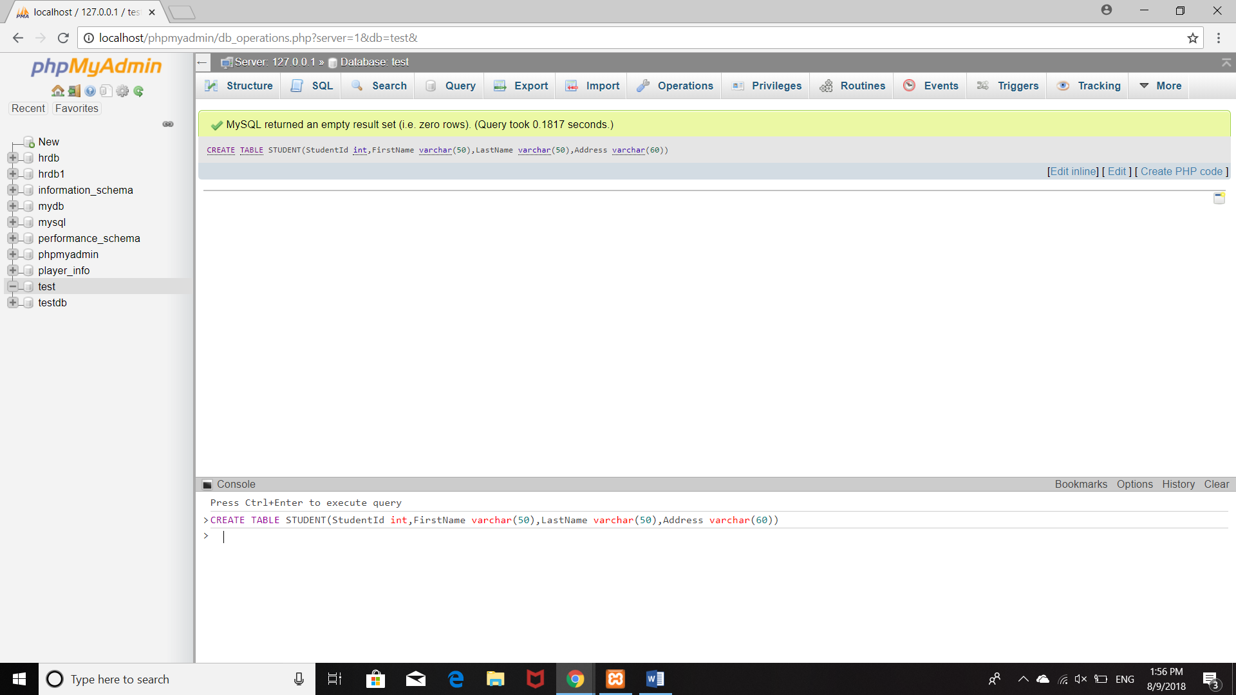

2.INSERT VALUES INTO TABLE:

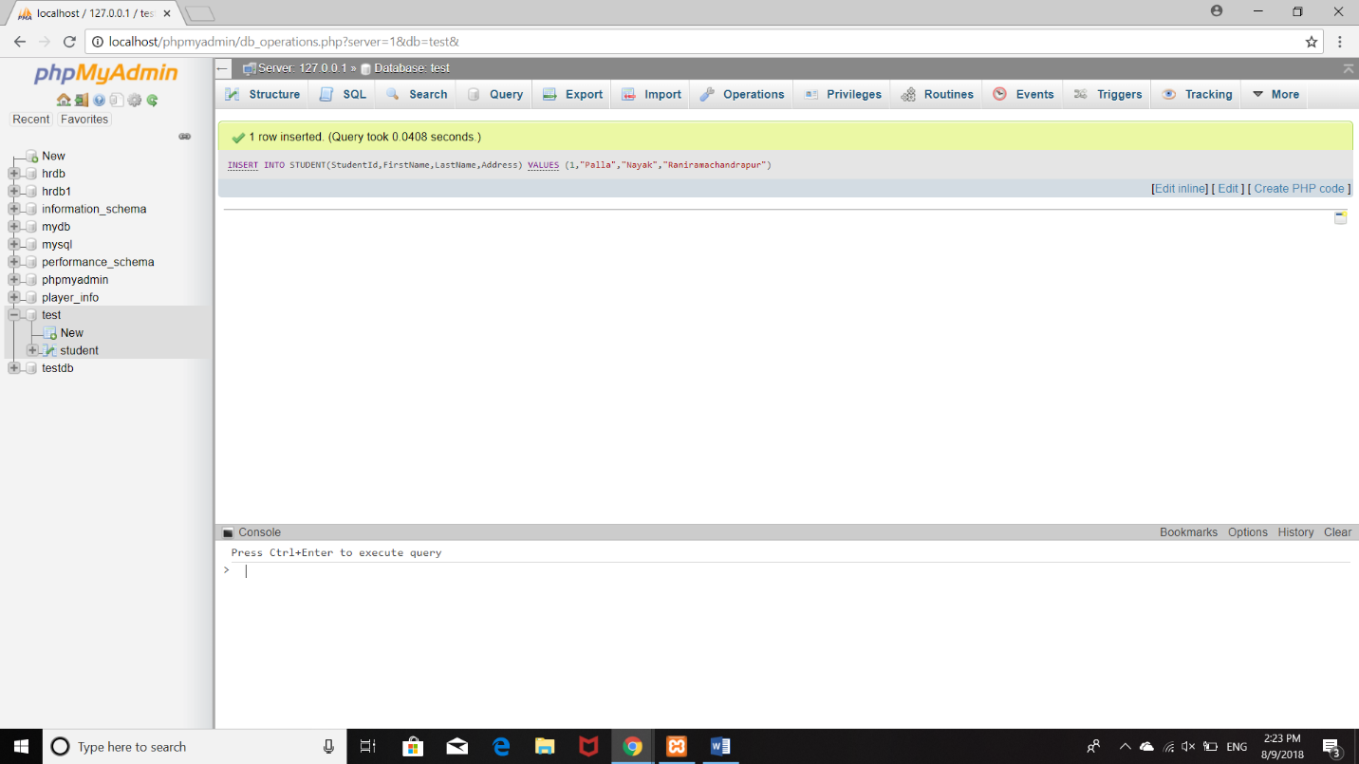

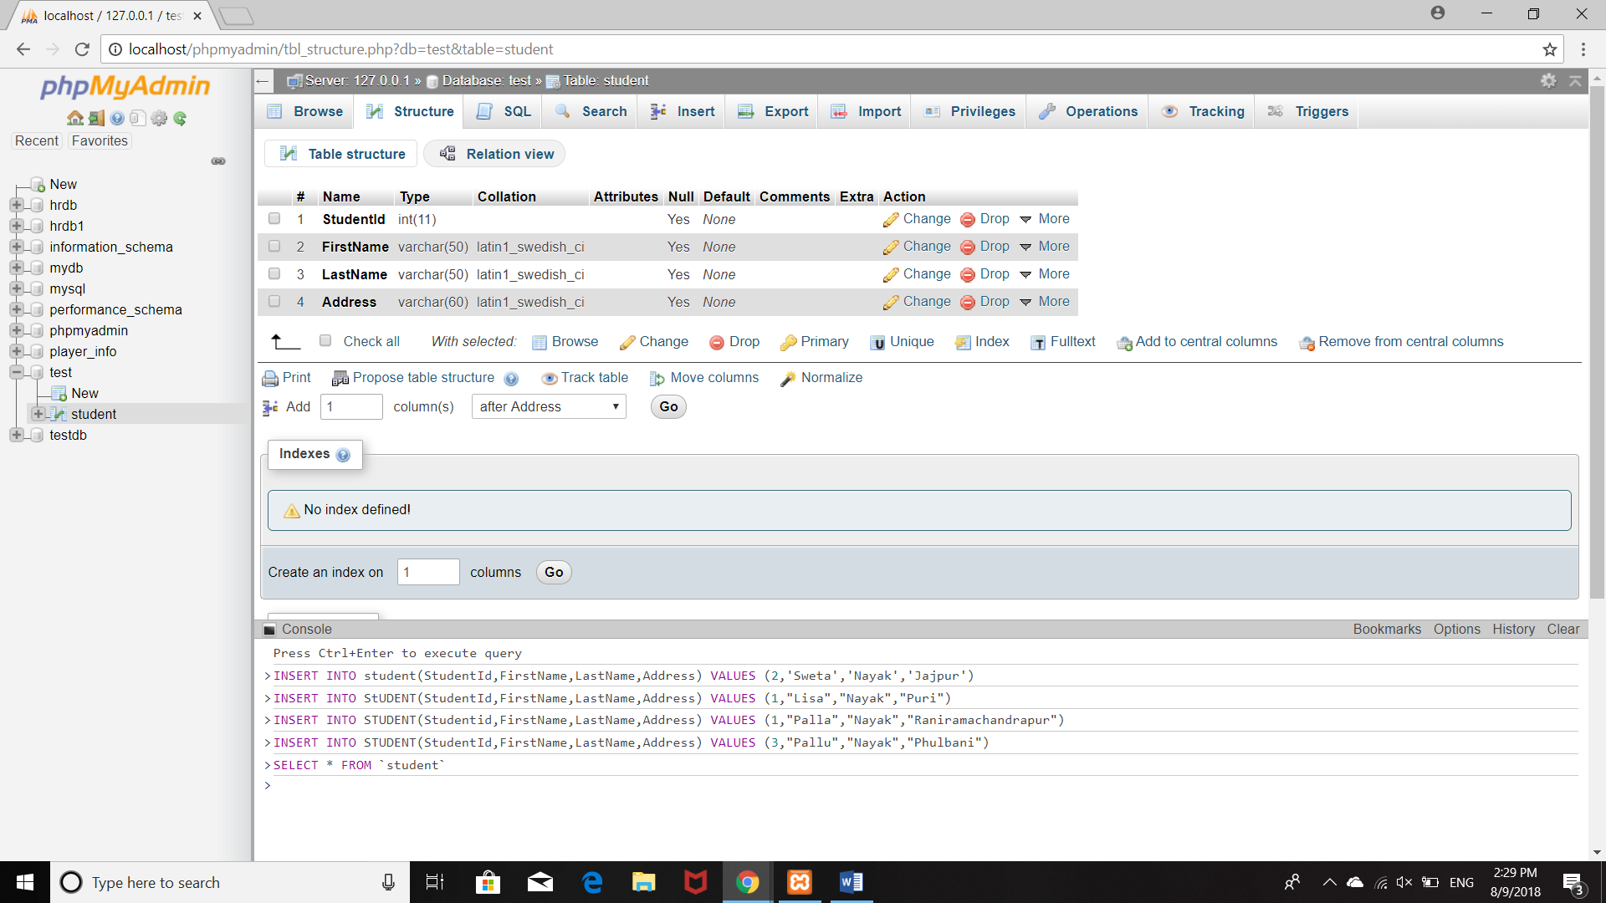

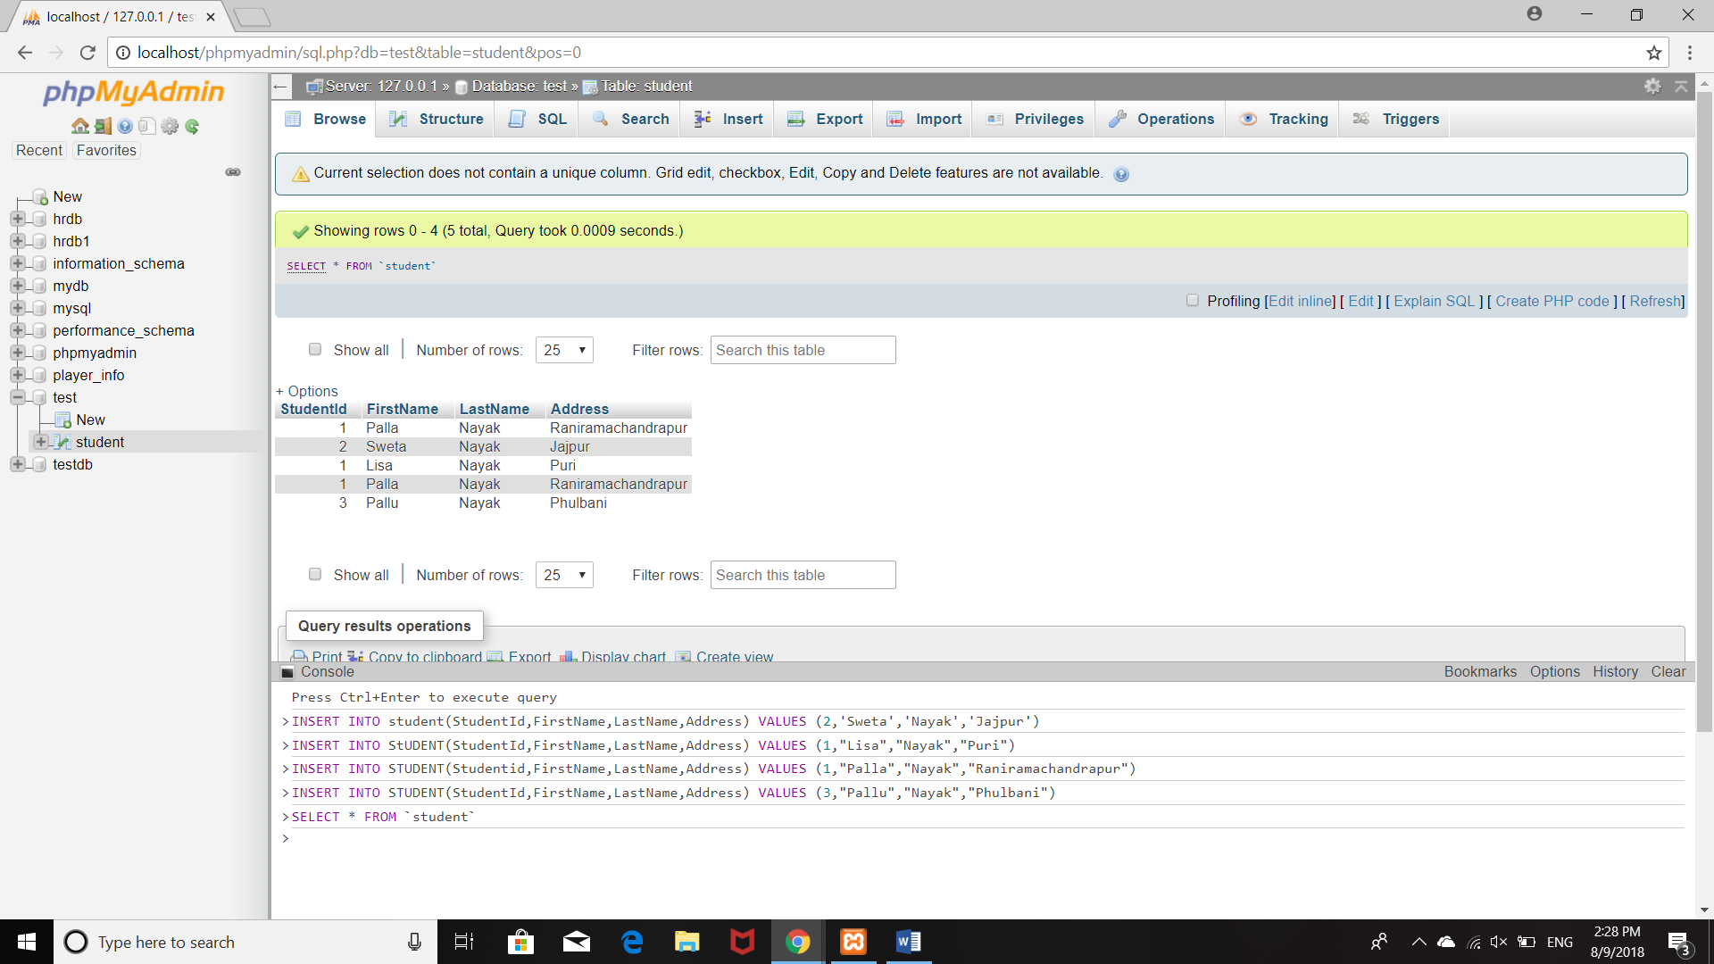

3.HOW TO GET ALL ELEMENTS FROM THE TABLE

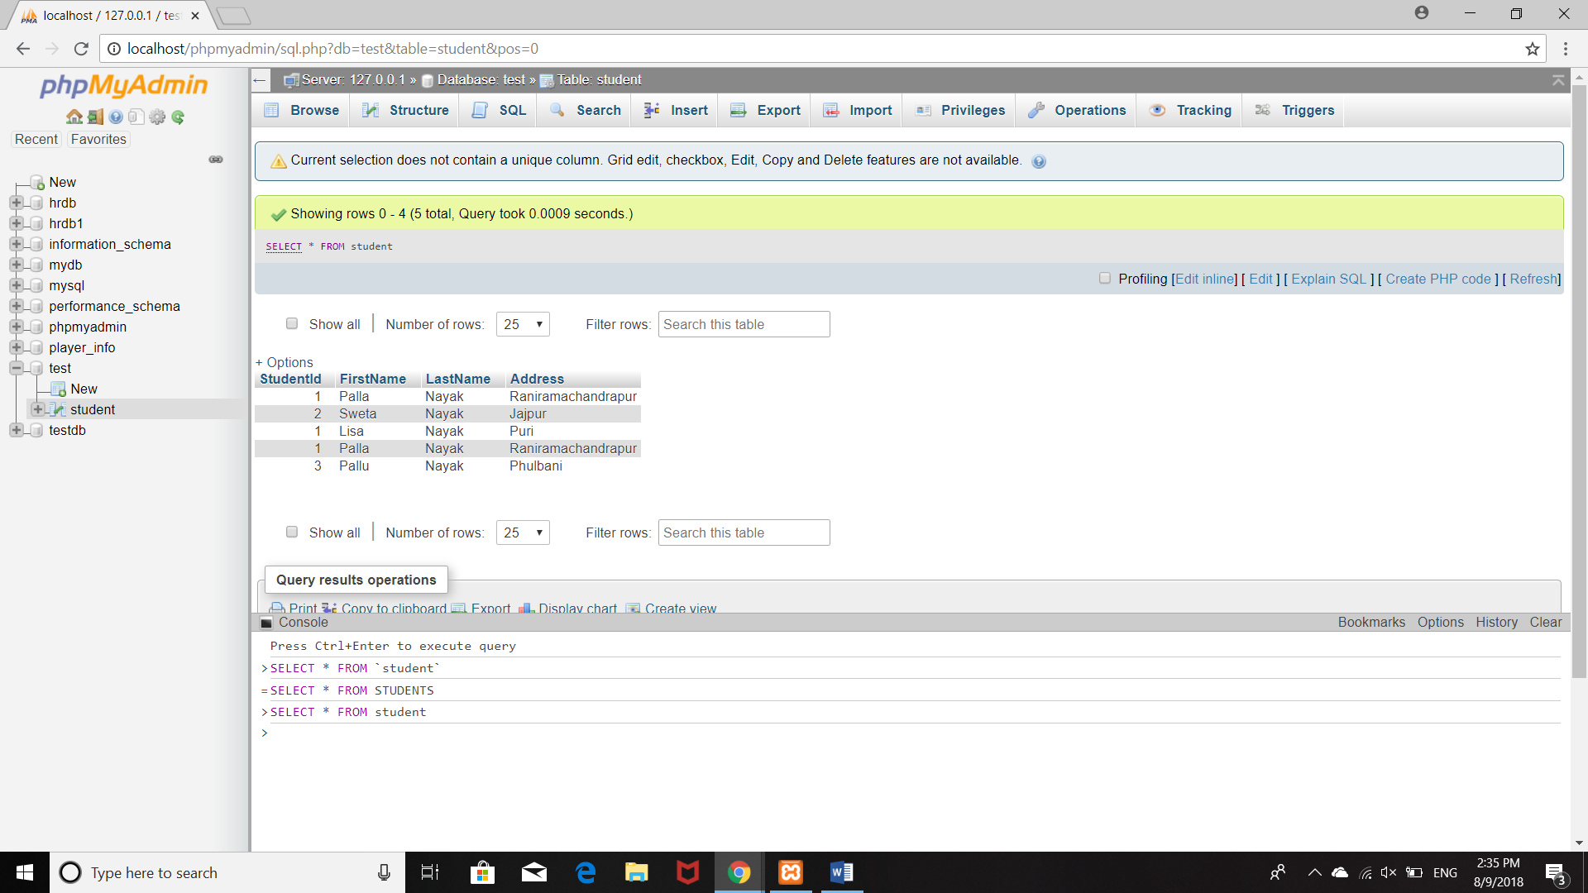

(GETTING ALL THE ELEMENTS OF A SINGLE ROW)

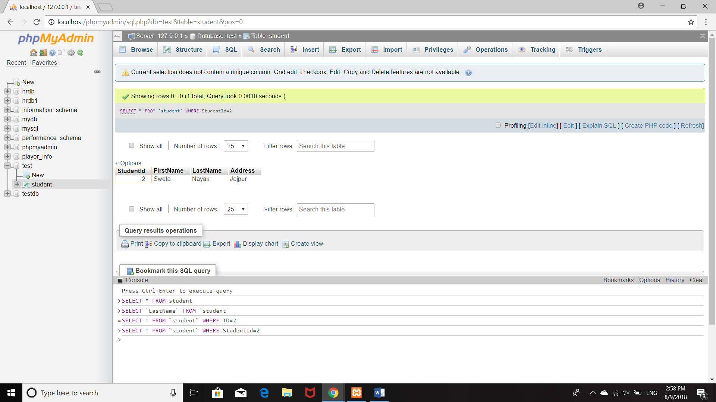

(TO GET THE VALUES OF A PARTICULAR TABLE)

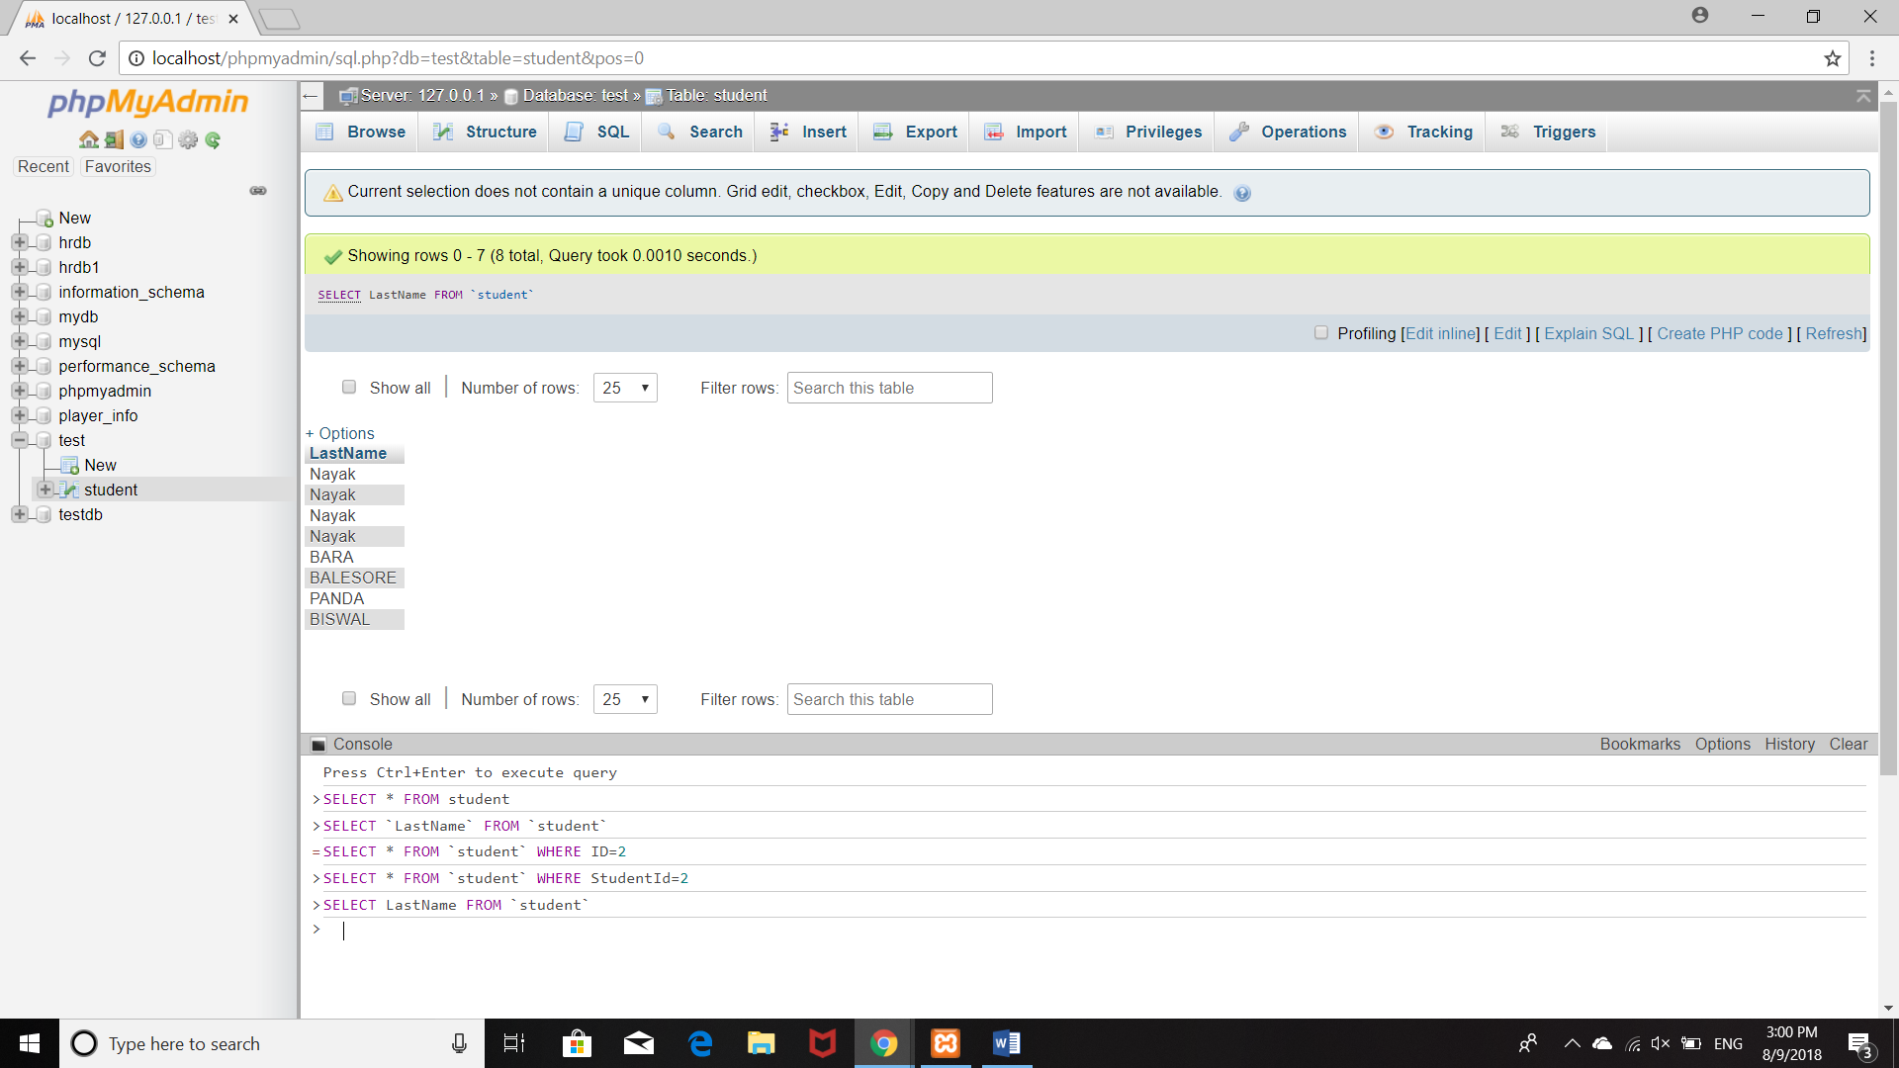

4.UPDATE A TABLE 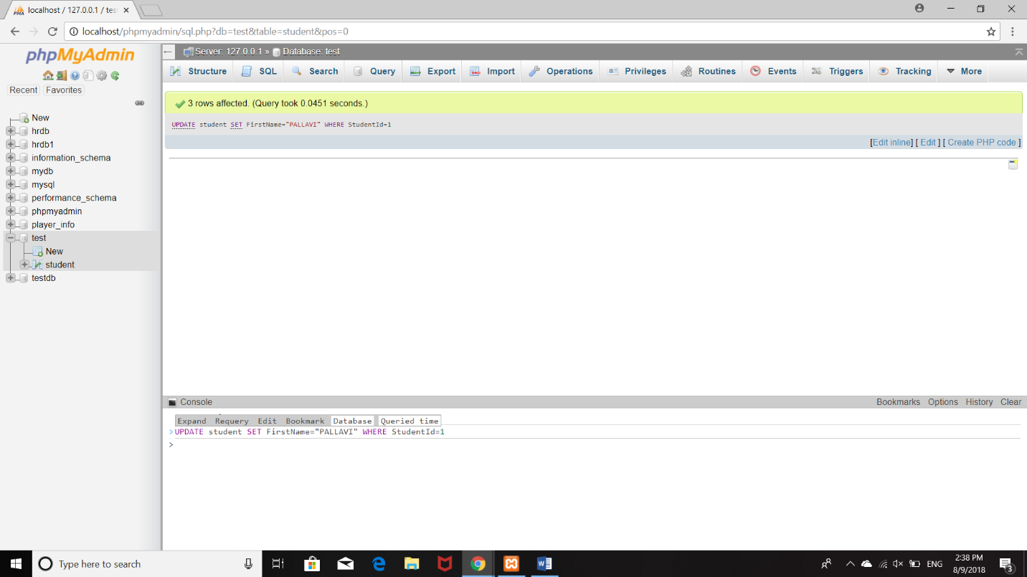

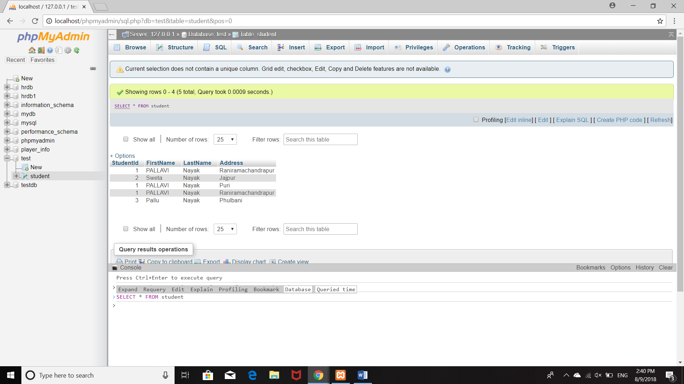

5.QUERY FOR DELETING A TABLE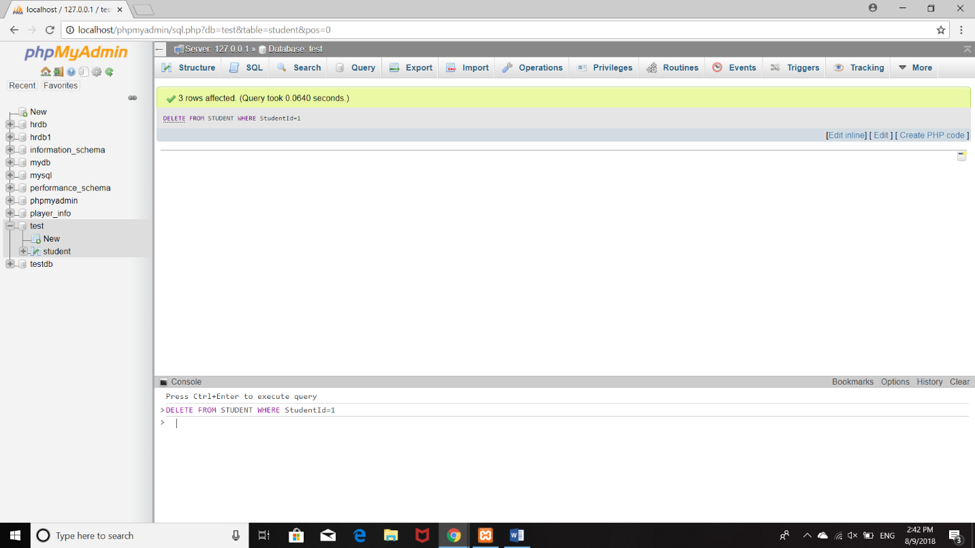

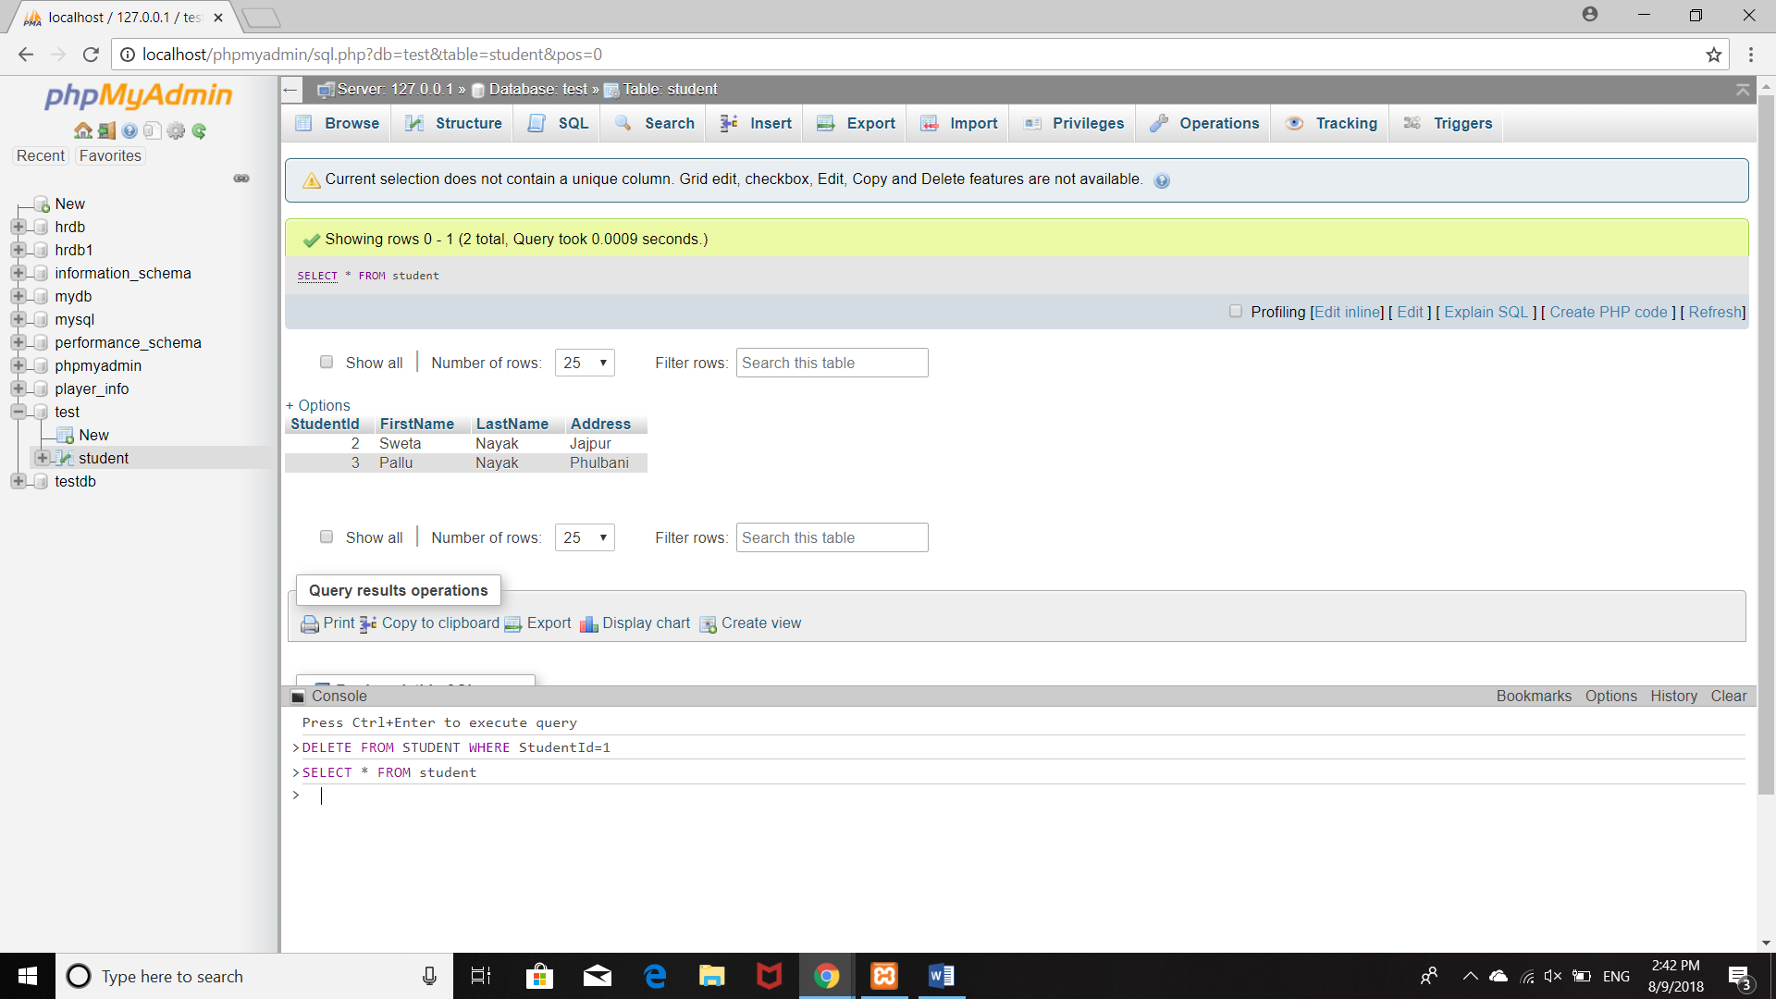

SQL CONSTRAINTS

1.NOT NULL

2.UNIQUE

3.CHECK

4.DEFAULT

5.INDEX

KEY CONSTRAINT

1.PRIMARY KEY

2.FOREIGN KEY

1.NOT NULL:

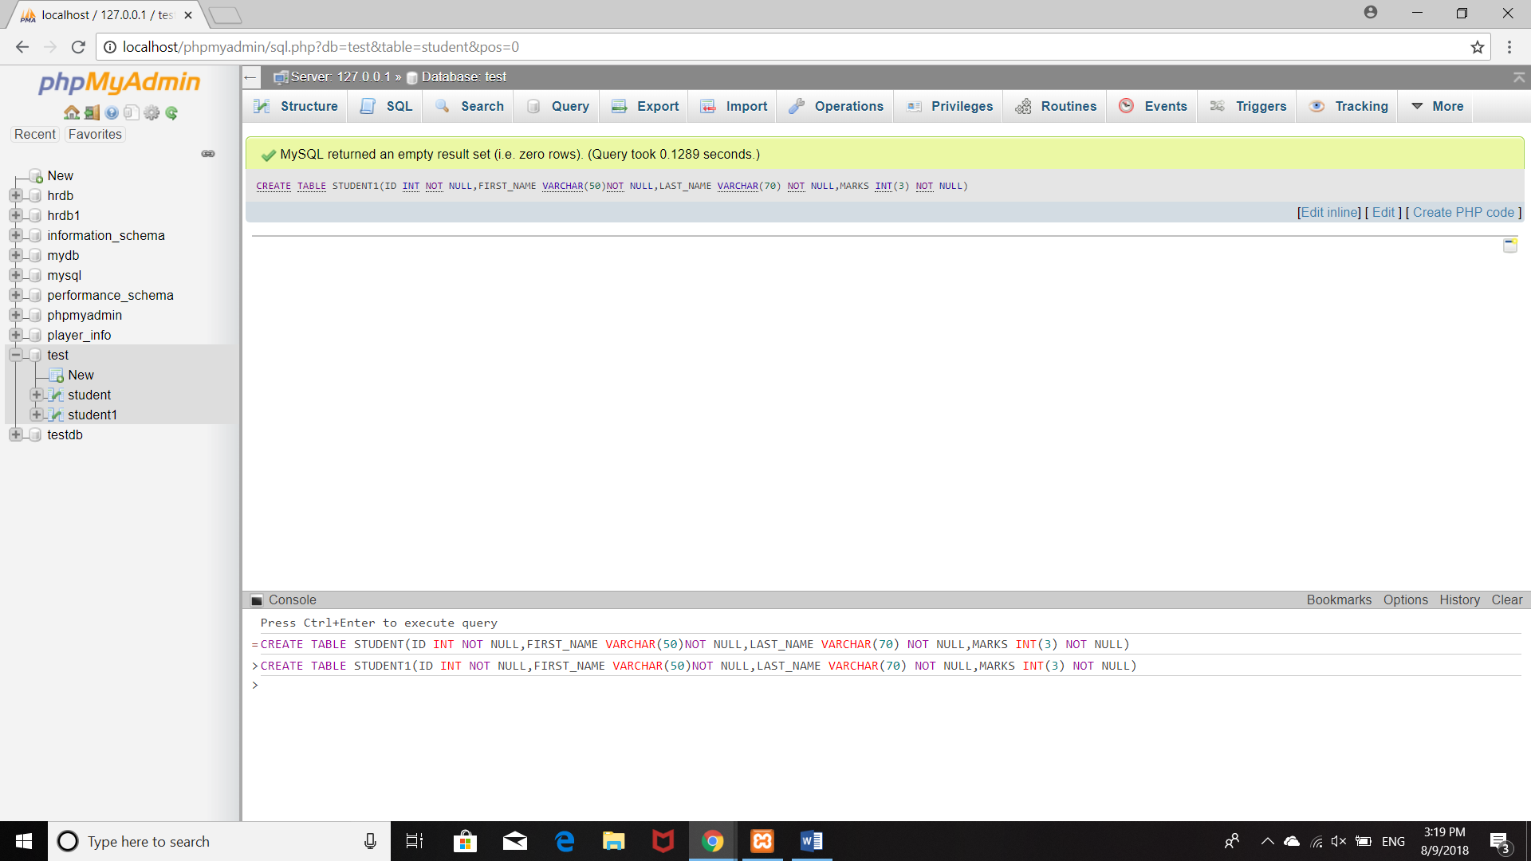

2.UNIQUENESS

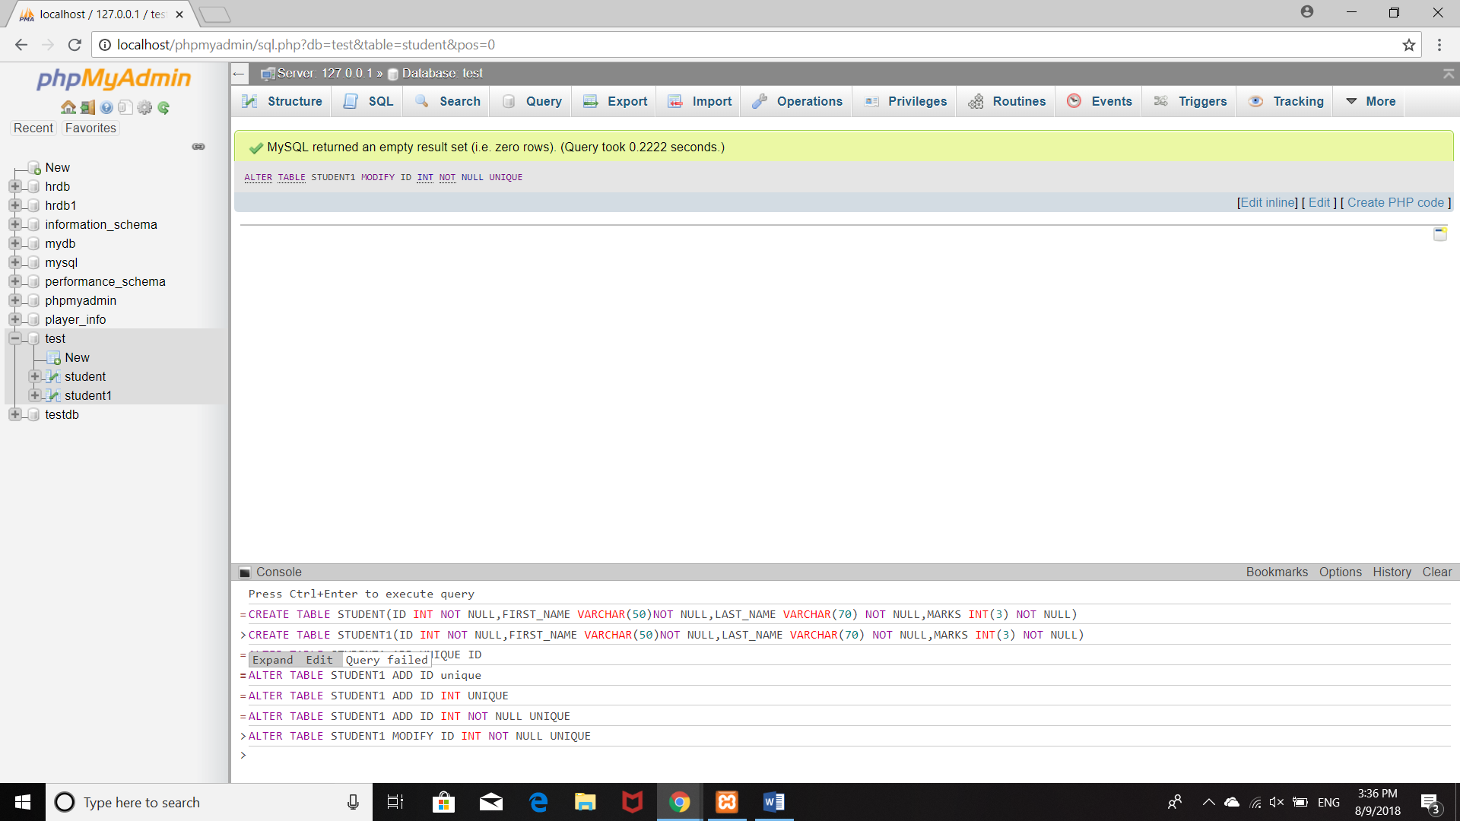

3.CHECK:

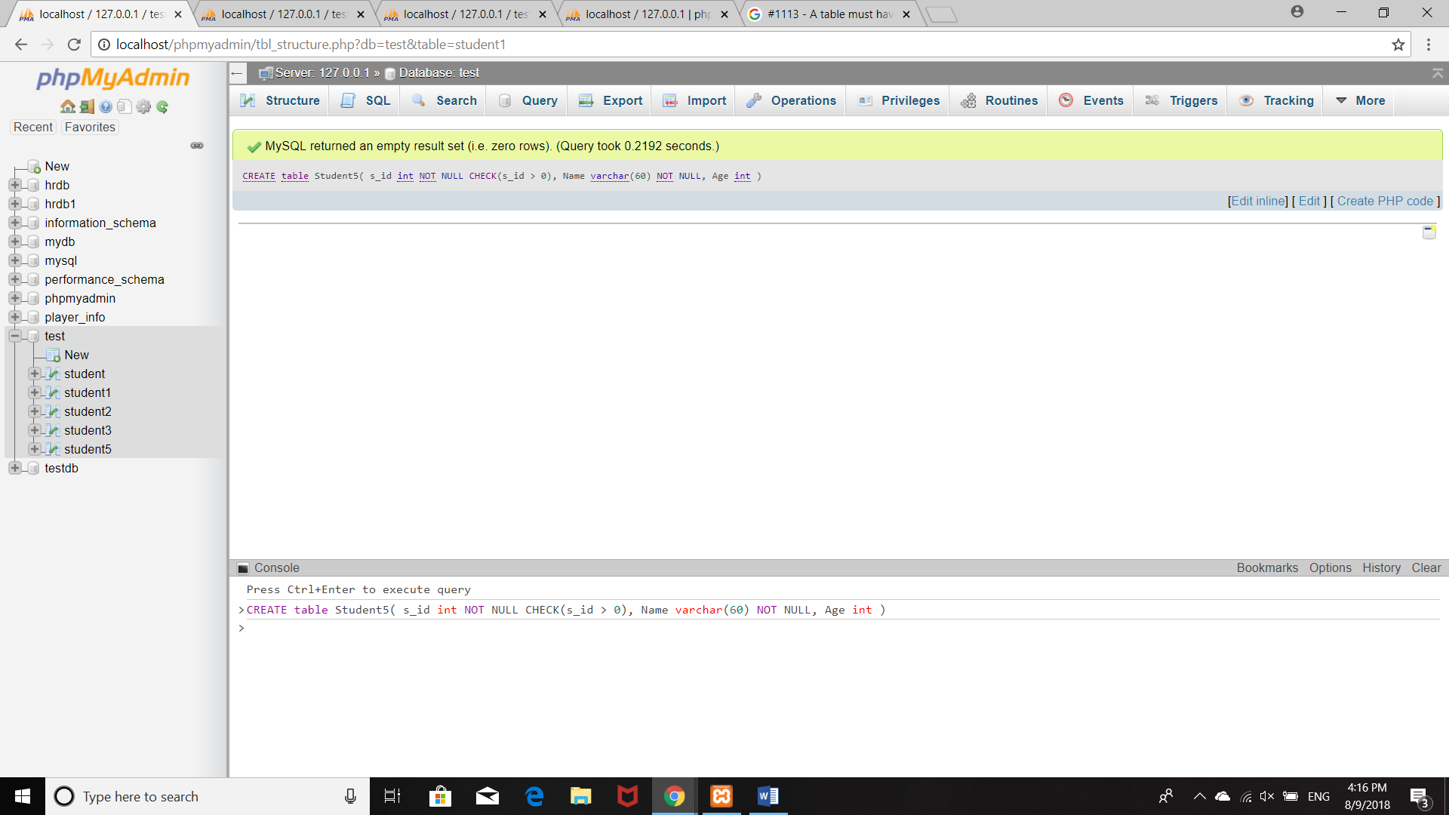

4.DEFAULT:

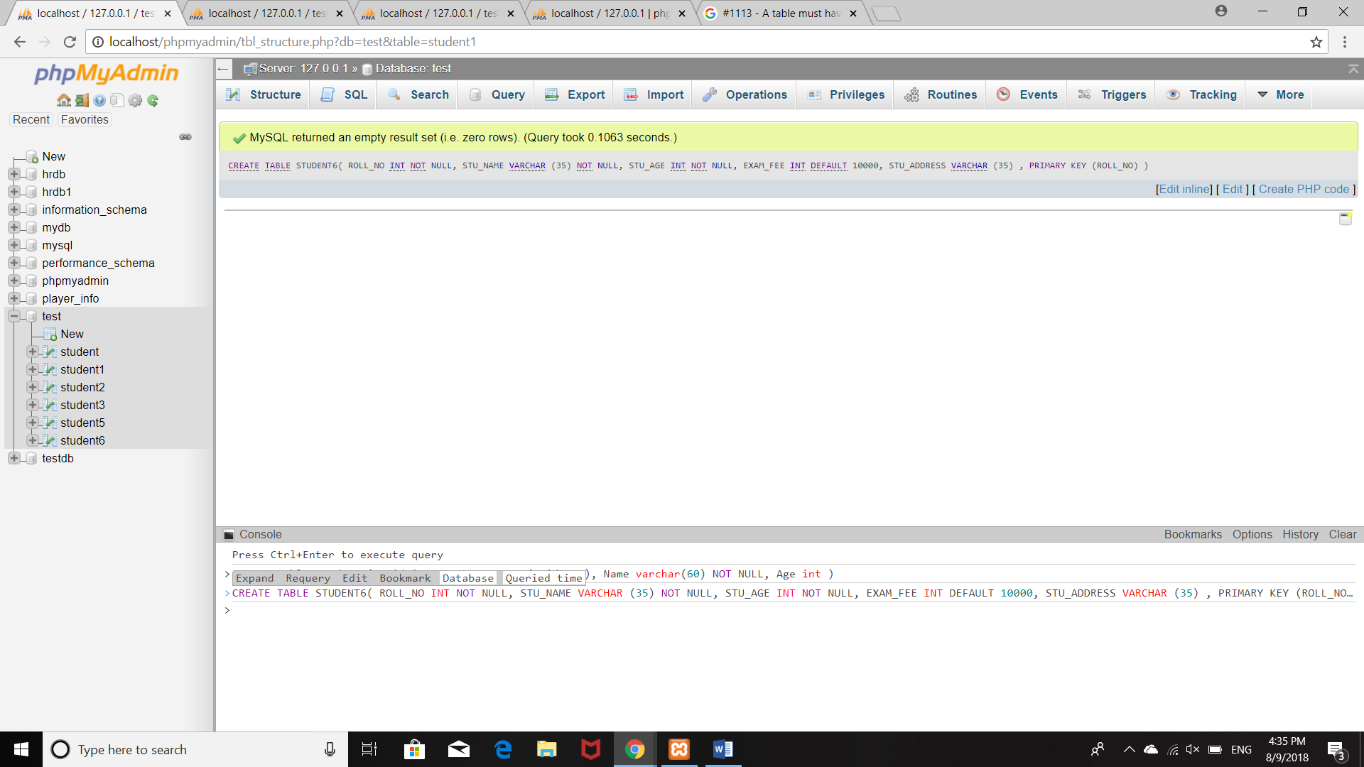

5.INDEX:

Index constraint is used to retrives the datas from the table very quickly.

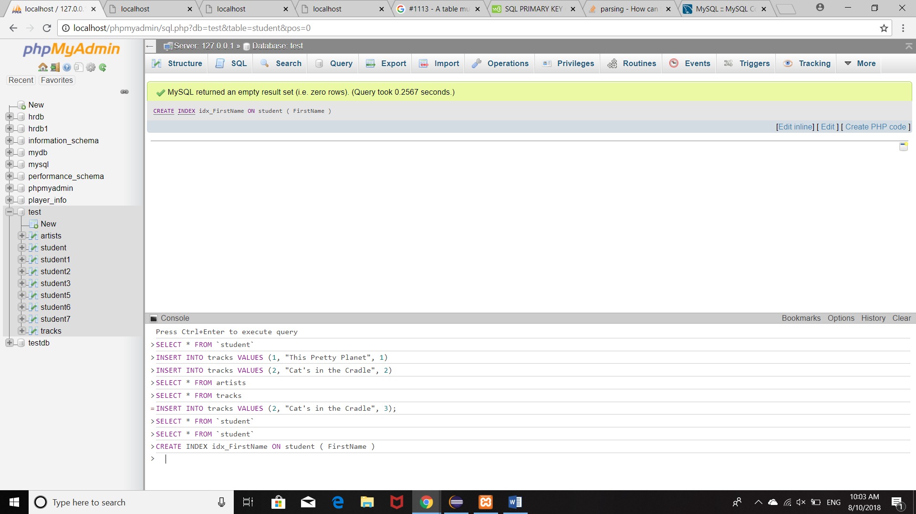

1.PRIMARY KEY CONSTRAINT:

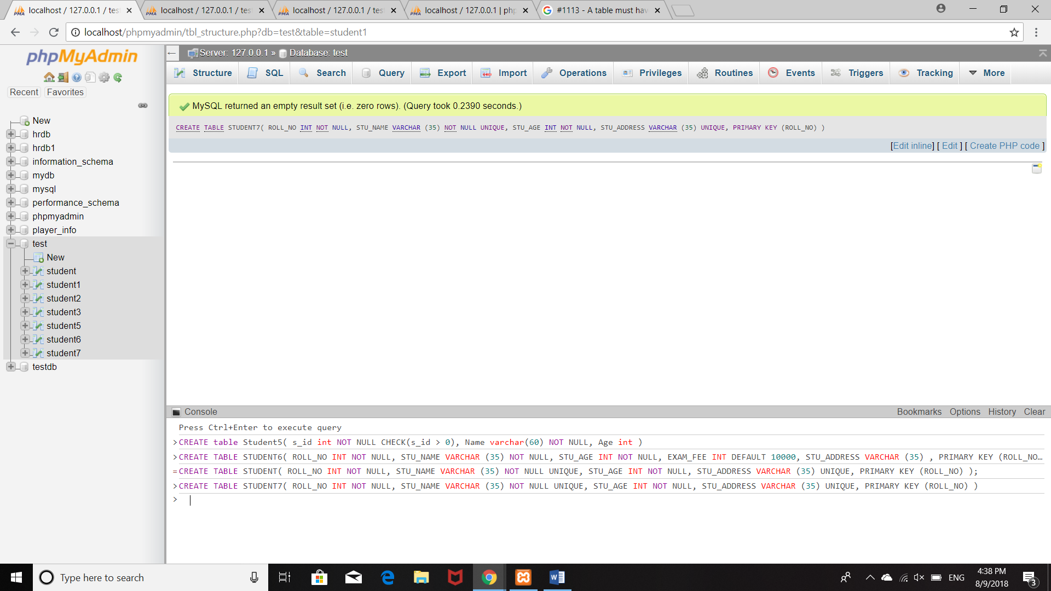

2.FOREIGN KEY:

This key is used to integrate between two table with some data i.e it relates two datas between two tables.primary key of one table is specified in another table

